**Project Description:**

**CraveCompass** is a basic IOS application developed and implemented by Andal, Andoy, and Mayo of MA Solutions to address the problems in the food market which revolves around economic and location data with regards to running establishments. The application’s intended function is to provide information about establishments, menus, and prices that would help provide information for people who want to explore the food market. The intended users of this program are the general population and tourists.

**Requirements Summary:**

|  |  |  |  |
| --- | --- | --- | --- |
|  | Processor Cores | Dual Core |  |
| **MINIMUM REQUIREMENTS** |  |  |  |
| OS | IOS 12 |  |
|  |  |
|  |  |  |  |
|  | RAM | 2 GB |  |
|  |  |  |  |
|  | Processor Cores | Quad Core |  |
| **RECOMMENDED REQUIREMENTS** |  |  |  |
| OS | IOS 17 |  |
|  |  |
|  |  |  |  |
|  | RAM | 4 GB |  |
|  |  |  |  |
| **OTHER REQUIREMENTS** | Permissions | 4G Data, Storage Permissions, Notification Permissions |  |
|  |  |  |  |

*Table 1. System Requirements IOS*

This application is designed for IOS devices which is designed for optimization and a lightweight framework. A minimum of 5 generations from the current IOS version is to be required while recommended requirements opt for IOS 17 which offers a smooth process.

**Prototype Description**

The prototype was designed using Figma as the workspace for this project. It is preferred due to the features available and the simplicity of the interaction which allows for prototyping much faster and more optimized.

**Crave Compass Link**

<https://www.figma.com/design/pD1jeZKpyQhnbxzg9OL0iD/System-Prototype?node-id=0-1&t=rSe18ty9GUcWIuIG-1>

**User Scenario:**

Mike is a foreigner who landed in the city and wants to eat around the city. The problem is that his brochure rarely mentioned any nice spots around the city. A quick search on the internet shows but fails to present any relevant prices. Most of the prices he found were outdated or overpriced, which is less useful to him. Finally, he just opened his food app and just used it as a reference point.

On his next visit, he found an application named CraveCompass which was already used by the locals. He installed and opened it and found the app full of various details that were helpful to him. This became his go-to app whenever he visited a random city to enjoy various foods available to him.

**CRAVE COMPASS MOCK-UP Sketch:**

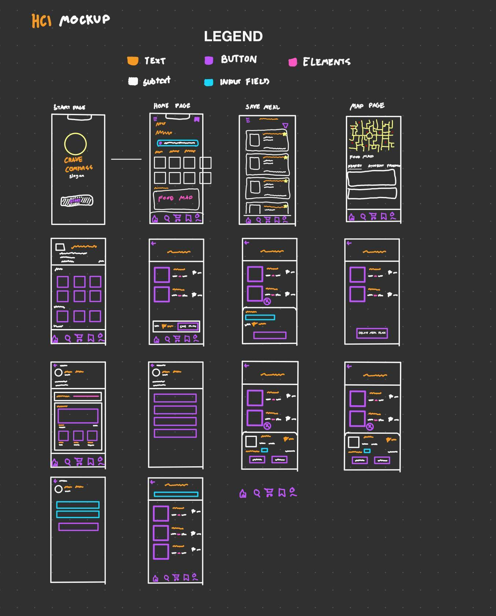

**CRAVE COMPASS MOCK-UP/Prototype:**

|  |  |  |
| --- | --- | --- |
| **Splash screen**  Contains the logo and a get started button for the users to start. | **Menu Screen**  Contains most of the functionalities including navigation buttons, item previews, food maps, and popular brands. | **Search Menu**  Contains a search field to enter desired food to view. |
| **Food Map**  Contains locations of nearest food locations and establishments. | **Establishment view**  Contains food available in selected establishments included with prices. | **Meal Plan Checkout**  Selected meals that can be stored as custom meals to be used as references. |
| **Saved Meal Plans** This contains the saved meal plans which can be viewed as references | **Account Menu**  This contains the local account which contains recent activities. | **Food Menu**  This contains manipulation when adding food to the meal plan. |
| **Saved Meals**  Displays saved meals added by user | **Custom Meal Menu**  Displays the saved custom meal plan | **Item Edit Menu**  Displays options for item. |
| **Edit Account Info**  Edit username and description (local) | **Account info**  Contains account and app manipulation (Only edit account info works) |  |

**Prototype Flow**

**Opening Program**

|  |  |
| --- | --- |
|  |  |

*Figure 1.1. Opening Program*

Figure 1.1 shows the opening of the application which is greeted by a splash screen and a get started button which proceeds to the Menu.

**Searching Item**

|  |  |
| --- | --- |
|  |  |

*Figure 1.2. Searching Item*

Figure 1.2 shows searching the item which can be accessed by Clicking either the search button on the navigation buttons at the bottom or clicking the search bar at the top of the menu.

**Viewing Food Map**

|  |  |
| --- | --- |
|  |  |

*Figure 1.3. Viewing Food Map*

Figure 1.3 shows the viewing of the Food Map which can be accessed by clicking the map photo on the menu.

**Adding to Meal Plan**

|  |  |  |  |  |
| --- | --- | --- | --- | --- |
|  |  |  |  |  |

*Figure 1.4. Adding meals to meal plan*

Figure 1.4 shows adding meals by first clicking the Food map or the available food, if food map is clicked, scroll down to see nearby establishments and click preferred, then when the Establishment menu is present, the user can click any, which a pop-up opens prompting the user to add to meal plan. The user then can open the meal plan check-out by clicking the center icon on the navigation.

**Viewing Meal Plan**

|  |  |  |
| --- | --- | --- |
|  |  |  |

*Figure 1.5. Viewing Meal Plan*

Figure 1.5 shows viewing Meal Plan which can be accessed through the ribbon icon beside the check-out icon. Which presents Saved meal plans that can be viewed.

**Editing Meal Plan**

|  |  |  |  |
| --- | --- | --- | --- |
|  |  |  |  |

*Figure 1.6.* Editing Meal Plan

Figure 1.6 shows editing items in the meal plan based on the user’s discretion. The same process as viewing the meal plan but has the additional step of tapping the item to edit quantity, or delete.

**Rationale:**

The team used Figma as a method for creating the prototype since it is an intuitive application that contains functionalities that are easy to understand and manipulate and allows for simultaneous editing which speeds up development work. There’s also a feature where Figma can simulate the final application based on the inputs of the Developers which allows for better prototyping. This comes at the cost of having an internet connection as a requirement which hinders full-time editing.

**Changes to the Requirements:**

The prototype has undergone several changes from the initial plans of the team to further simplifications of the program to save time. Another is the use of Heuristics which reveals flaws with the design that need modifications such as the removal of the delivery function which will require more resources to be allocated to the application which becomes unviable, especially for a prototype. This instead is replaced by a save feature where the user can save meal plans that can be used as references.

**Initial Evaluation Plan:**

Due to conflicts in schedules, availability of the members, and limitations in time, the team is unable to conduct this physically or online. Instead, the evaluation is to be conducted asynchronously, through Forms with guidance from the development team. While this limits the effectiveness of evaluations, this creates another factor which is how users are to be expected when there’s no guidance from the developers.

**Usability Specifications**

The development of this Prototype aims to address the following factors based on the use of the users such as:

* Effectiveness: This allows us to determine whether or now the prototype functions or the level of its applicability in real-world situations.
* Efficiency: This allows us to determine whether the prototype is easy to follow/use.
* Utility: This aims to provide a measure of the functionality and features of the program.
* Learn Ability: This will determine how easy the application is to understand and utilize in various cases.
* Memorization: This will determine how the users easily understand the flow of the program.

Population

Around 5-10 participants will be selected to test the prototype. They will be required to do given tasks that aim to test the functionality of the prototype and determine its usefulness. Examples include navigating the menu, adding an item, and changing account information. These tasks will determine the success of the prototype.

**Prototype Tasks**

The tasks for this prototype are continuous as the intended function of the prototype is to have the functionality to be fluid enough that at most there’s 1 navigation that can head straight back to the main page. Provided below are the tasks that users are required to perform to consider the functionality. These are categorized as Main, Navigational, and Manipulation:

* Enter the Program (Navigation)
* View Food Map (Navigation)
* View Item Price (Main)
* Add Item to Meal Plan Checkout (Main)
* Save Meal Plan (Main)
* View Meal Plan (Manipulation)
* Edit Meal Plan (Manipulation)
* Delete Meal Plan (Manipulation)

These tasks are selected to be able to test all functional features of the prototype which provides:

* Navigational Challenges
* Memorization

**Roles**

This team will be sending out the Forms with the attached link for the application which the respondents will be given ample time to test and start the application testing.

|  |  |
| --- | --- |
| DEVELOPER/DESIGNER | TASK(s) |
| ANDAL, ETHAN | Finding participants |
| ANDOY, JERVIN | Will record Manipulation of the application. |
| MAYO, JONATHAN LANCE | Performs QA with the user tests and records user experience. |

*Table 1. Team member Tasks*

|  |  |  |  |
| --- | --- | --- | --- |
| ***Navigation*** | *Within 1 minute* | *Highly Acceptable* | *Successful* |
| *Above 1 minute* | *Not acceptable* | *Unsuccessful* |
| ***Main*** | *Within 1 minute* | *Highly Acceptable* | *Successful* |
| *Above 1 minute* | *Not acceptable* | *Unsuccessful* |
| ***Manipulation*** | *Within 1 minute* | *Highly Acceptable* | *Successful* |
| *Above 1 minute* | *Not acceptable* | *Unsuccessful* |

*Table 3. Time interpretation*

Table 3 is the interpretation of how long the users navigate through the tasks which will determine the success rate of the application. The table will be used as a reference for interpretation of the design and success rate of the application.

**Heuristic Evaluation**

As standard practice, CraveCompass will be utilizing the 10 usability Heuristic method of evaluation as a benchmark on how the application functions.

**Visibility of System Status:**

The Prototype will keep the participants informed on what is happening in the Prototype.

**Match Between System and Real World:**

The prototype speaks the user’s language, with familiar words, phrases, and concepts rather than system-oriented terms. Follow real-world conventions, making information appear in a natural and logical order.

**User control and Freedom:**

The Prototype offers to deal with mistake provided clearly marked “Emergency Exit”. To leave the unwanted state without going through an extended an extended dialogue. Support undo and redo.

**Consistency and Standards:**

Users will not have to worry whether different words, situations, or actions mean the same thing.

**Error Prevention:**

Error Messages are Carefully designed which prevents a problem from occurring in the first place.

**Recognition rather than recall:**

Make objects, actions, and options visible. The user does not have to remember

information from one part of the dialogue to another. Instructions for use of the prototype

is visible and easily retrievable whenever appropriate.

**Flexibility and Efficiency of Use:**

The prototype caters to both experienced and inexperienced users. Users readily tailor

frequent actions

**Aesthetic and Minimalist Design:**

The prototype does not contain information which is irrelevant or rarely needed. Every

extra unit of information in a dialogue competes with the relevant units of information and

diminishes their relative visibility.

**Help Users Recognize, Diagnose, and Recover from Errors:**

Error messages are explained in plain language (no codes), precisely indicating the

problem, and constructively suggest a solution.

**Help and Documentation:**

Users can easily find help and documentation when need to interact with the prototype.

This information is easy to search for.

**Participant Survey and Feedback**

After conducting the forms:

|  |  |
| --- | --- |
| **Data Gathering Method** | **Description** |
| Survey (Quantitative) | After conducting, the team will include a post-survey for gathering quantitative data with regards to the user experience of the program. This will be using a 5-point Likert scale as reference. |
| Feedback (Qualitative) | The post-survey will also contain information with regards to the Feedback of the users to ensure openness and customer feedback is met and identified. |

*Table 4. Data Gathering Methods*

The table above showcases the different data-gathering methods that will be utilized by the team in conducting the surveys.

|  |  |
| --- | --- |
| QUESTION | METHOD OF ANSWER |
| SECTION 1 | |
| PARTICIPANT NUMBER | SHORT ANSWER (QUALI) |
| On a scale of 1 to 5 how would you rate your experience with the Sasha Prototype | 5-Point Scale |
| On a scale of 1 to 5 how was the UI design of the prototype |
| How easily were you able to follow the tasks provided |
| **SECTION 2:** **Features of the Prototype** | |
| Enter the Program (Navigation) | 5-Point Scale |
| View Food Map (Navigation) |
| View Item Price (Main) |
| Add Item to Meal Plan Checkout (Main) |
| Save Meal Plan (Main) |
| View Meal Plan (Manipulation) |
| Edit Meal Plan (Manipulation) |
| Delete Meal Plan (Manipulation) |
| **Section 3: Feedback Section** | |
| USER FEEDBACK | SHORT ANSWER (QUALI) |

*Table 5.Survey Questionnaire*

Table 5 will be the format for the questionnaire that will be used in the evaluation of the prototype. This will be handed over to the participants as it also contains the link to access the prototype. This survey can be accessed through this link <https://docs.google.com/forms/d/e/1FAIpQLSeBvzWaW7Jd63WEGXFtvsCPEhkVSJKsaRGHRSnLiZ5ypFjwzg/viewform?usp=sf_link>

|  |  |  |  |
| --- | --- | --- | --- |
| **Mean** | **Scale** | **Descriptive Equivalent** | **Classification** |
| 4.5 - 5.0 | 5 | Highly Acceptable | SUCCESSFUL |
| 3.5 - 4.49 | 4 | Acceptable |
| 2.5 - 3.49 | 3 | Moderately Acceptable | NEUTRAL |
| 1.5 - 2.49 | 2 | Fairly Acceptable | FAILED |
| 1.0 - 1.49 | 1 | Not acceptable |
| **Overall Mean** |  | **Overall Descriptive Equivalent** |  |

*Table 6. 5-point Likert Scale Survey Interpretation*

*Table 6 presents the interpretation of the question provided in the forms. The survey will determine the applicability of the design and Functions based on the results.*